# Air Optix colors

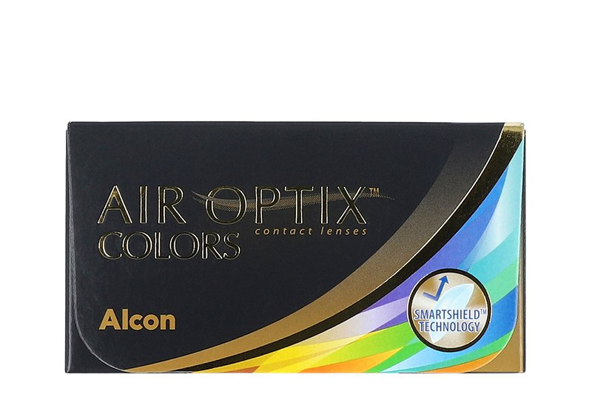

Product information

|  |  |
| --- | --- |
| **Brands** | Air Optix |
| **Availability** | In Stock |
| **Replacement** | 1 month daily wear |
| **Material** | Lotrafilcon B |

Description

**Finally, a comfortable colored contact lens - Air Optix Colors (sometimes referred to as Air Optix Aqua Colors) come in a pack of 6 lenses per box, in a variety of beautiful colors**.